Database credentials
# Source: AI Source: Provided by: [Data Path: Persons Table -> ID Column: 1, Name_En Column: Motasem Essam] -> From: [ChatGPT] on [1/18/2026]
Database credentials are the authentication details an application or user uses to connect to a database and perform actions like reading, writing, or updating data.

🗄️ What are Database Credentials?
# Source: AI Source: Provided by: [Data Path: Persons Table -> ID Column: 1, Name_En Column: Motasem Essam] -> From: [ChatGPT] on [1/18/2026]
They usually consist of:
- Username → identifies the database user
- Password → authenticates the user
- (Often combined with host, port, and database name)
Example
DB_HOST=localhost
DB_PORT=3306
DB_NAME=app_db
DB_USER=app_user
DB_PASS=StrongPassword!123

🛠️ How it works
# Source: AI Source: Provided by: [Data Path: Persons Table -> ID Column: 1, Name_En Column: Motasem Essam] -> From: [ChatGPT] on [1/18/2026]
- App tries to connect to the database
- Sends username + password
- Database validates the credentials
- If allowed → connection is opened
- Permissions define what the user can do

📍 Where it’s used
# Source: AI Source: Provided by: [Data Path: Persons Table -> ID Column: 1, Name_En Column: Motasem Essam] -> From: [ChatGPT] on [1/18/2026]
- Applications (backend services)
- Web servers
- Data analytics tools
- Admin tools (phpMyAdmin, pgAdmin)
- Microservices

🎭 Types of database credentials
# Source: AI Source: Provided by: [Data Path: Persons Table -> ID Column: 1, Name_En Column: Motasem Essam] -> From: [ChatGPT] on [1/18/2026]
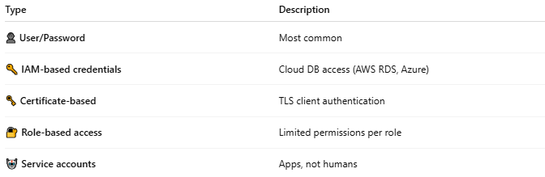
Type | Description
👤 User/Password | Most common
🔑 IAM-based credentials | Cloud DB access (AWS RDS, Azure)
🗝️ Certificate-based | TLS client authentication
🔐 Role-based access | Limited permissions per role
🤖 Service accounts | Apps, not humans

✅ Advantages
# Source: AI Source: Provided by: [Data Path: Persons Table -> ID Column: 1, Name_En Column: Motasem Essam] -> From: [ChatGPT] on [1/18/2026]
- Direct control over database access
- Fine-grained permissions
- Works across all DB engines

⚠️ Disadvantages
# Source: AI Source: Provided by: [Data Path: Persons Table -> ID Column: 1, Name_En Column: Motasem Essam] -> From: [ChatGPT] on [1/18/2026]
- High impact if leaked
- Often hard-coded by mistake
- Password rotation can be risky
- Over-privileged users are common

🔒 Best practices
# Source: AI Source: Provided by: [Data Path: Persons Table -> ID Column: 1, Name_En Column: Motasem Essam] -> From: [ChatGPT] on [1/18/2026]
- Use least privilege (no root/admin for apps)
- Store credentials in environment variables or secrets managers
- Rotate passwords regularly
- Enable SSL/TLS connections
- Never expose DB credentials to the frontend

🧠 Authentication factor
# Source: AI Source: Provided by: [Data Path: Persons Table -> ID Column: 1, Name_En Column: Motasem Essam] -> From: [ChatGPT] on [1/18/2026]
- Something you know → password
- Something you have → certificate / IAM role (if used)

🧨 Common mistakes
# Source: AI Source: Provided by: [Data Path: Persons Table -> ID Column: 1, Name_En Column: Motasem Essam] -> From: [ChatGPT] on [1/18/2026]
- Using root in production
- Reusing DB credentials across environments
- Committing .env files to Git
- Giving ALL PRIVILEGES unnecessarily

